Missions in the Metaverse Research

- Microsoft’s virtual reality platform is called AltspaceVR. AltspaceVR is the leading platform for live, virtual events, empowering artists, brands, and businesses to easily design meaningful experiences that foster community and connection. (AltspaceVR 2022)
- As new opportunities like the metaverse emerge, Life.Church continues to be passionate about leveraging technology to bring hope to people where they are, especially those who might not otherwise set foot in a physical church. (Lea 2021)
- With 15 years of online ministry experience (including services in Second Life in 2007), Life.Church has found that people are often more willing to let their guard down and have deep, meaningful conversations more quickly from the safety of anonymity than they are face-to-face. (Lea 2021)
- “It’s not a ministry, it’s not a little side thing that we’re doing,” Soto told ChurchLeaders. “This is the body of Christ in the metaverse.” (Lea 2021)
- DJ Soto, the founder and bishop of VR Church, He pointed out that churches tend to be slow to adopt new technologies, which he believes is “unfortunate,” and he encouraged churches to be more open to these developments. “I think that the future is digital, virtual or augmented,” he said. (Lea 2021)
- Pastor and “Analog Church” author Jay Kim believes there are benefits to technology, but does not think true discipleship can take place without being in person. “Discipleship is about proximity and practice,” he said, “that we live closely with Jesus and that we practice the way of Jesus and that way is by its very nature communal.” According to Kim, “If everything is online and you believe the church to be a peddler of Christian content, then church becomes nothing more than Netflix.” (Lea 2021)
- We believe God loves the metaverse and wants everyone to know it. (VR Church 2022)
  - Watch the replay at https://www.youtube.com/watch?v=76BQhk_h3nw
- We believe everyone is welcome to church. It doesn’t matter if you believe in God or not. (VR Church 2022)
- Jate Earhart LOVE CLAN A church on Twitch. (VR Church 2022)
- Jason Poling Cornerstone VR A physical church that launched a metaverse campus. (VR Church 2022)
- DJ Soto VR CHURCH A church that exists entirely in the metaverse. (VR Church 2022)
- “Church planting movement” (VR Church 2022)
- MMO = Massively Multiplayer Online, Below are examples of where MMO Church is cultivating loving spiritual communities. (VR Church 2022)
  - WATCH -> https://www.twitch.tv/videos/1424906460
- 1. GET A VR HEADSET (VR Church 2022)
  - Confusion exists about which VR equipment to use because many VR headsets line the store shelves. However, not all headsets represent a true VR experience.
  - Our general recommendation is that anything by Oculus is a good option. We highly recommend the Oculus Quest 2.
  - For you hardcore gamers and technologists who want the best VR experience, we recommend the Valve Index. Take note that you will need a powerful computer with a good graphics card for the Valve Index.
  - Here’s an article about the "8 Best VR Headsets for VRChat In 2020” / https://smartwatchfan.com/best-vr-headset-for-vrchat/
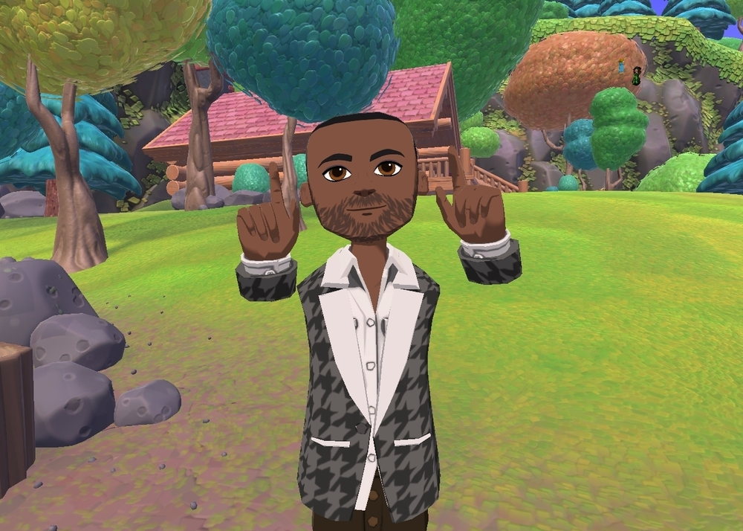
- 2. DOWNLOAD ALTSPACEVR (VR Church 2022)
  - Although our church exists in many metaverses (VRChat, RecRoom, AltspaceVR, Facebook Horizons), we recommend first time visitors attend VR Church in AltspaceVR, a social VR platform.
  - If you have never experienced the metaverse, you are about to embark on an adventure. You will meet people from all over the world in a dynamic environment with many worlds to explore.
  - Before visiting VR Church in AltspaceVR, take time to create an account, customize your avatar, and complete the tutorial. Following these steps will provide a solid experience for your first time in church.
  - Click HERE to download AltspaceVR.
  - (Although we highly recommend using a VR headset, please note that AltspaceVR has a desktop mode that can be experienced on a laptop or PC.)
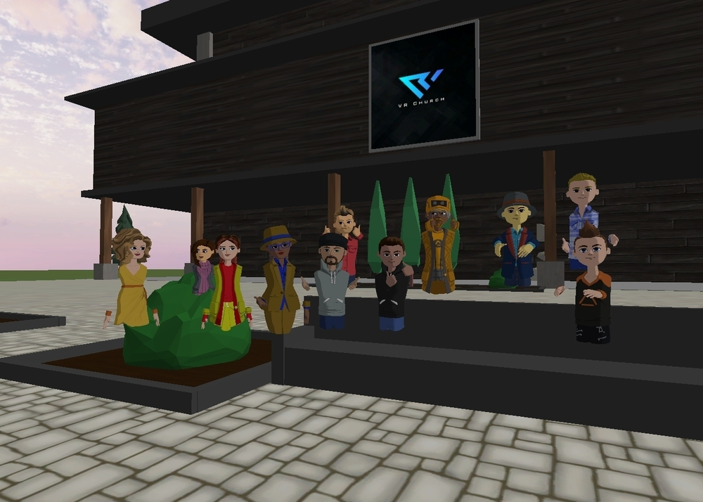
- 3. EXPERIENCE VR CHURCH (VR Church 2022)
  - We are so excited you made it this far! Look for our events on Sunday in the events section of AltspaceVR. We also have multiple experiences that meet during the week. Join our Discord server by clicking HERE to keep up to date. This is a great way to stay connected with the life of the church outside of VR. Finally, if you are completely lost and would like a personal guide, please contact us on Discord and ask for a VR Church Host. They will guide you all along the way. For more specific information about our gatherings, please see the “Metaverse” section of the website.
- 12 Biblical Reasons the Church Gathers In Person (Carl – Online Church 2022)
- 5 Purposes of Live Streaming a Church Service (Carl – Online Church 2022)
- 6 Things that Happen When We Don’t Gather Together (Carl – Online Church 2022)
- 8 of Satan’s Best Temptations to Keep You Out of Church (Carl – Online Church 2022)Your Presence Reveals Your Priorities: 5 Steps Forward Together To Gather (Carl – Online Church 2022)
- D.J. Soto, Founder of VR Church, and Nona Jones of Meta/Facebook give a primer on the metaverse, how Web3 will be different from Web2 and Web1, VR church, NFTs, DAOs, blockchain and more as we explore what’s next online and in real life. (Nieuwhof CNLP470 2022)
- Avatar as a 3D representation of myself? DJ Soto preaches as an avatar (Nieuwhof CNLP470 2022)
- Web1.0 – drop in and out, mostly text, content consumption (Nieuwhof CNLP470 2022)
- Web2.0 – more social, interact with content, share, like, recommend the content, communal type of experience (Nieuwhof CNLP470 2022)
- Web3.0 – semantic web, integrate all of the available technologies into a more immersive experience, decentralizing, democratizing information (Nieuwhof CNLP470 2022)
  - “walled gardens” – pay gates
- Computing paradigms – DOS, tactical/visual (Windows/Mouse), Smart Phone revolution, Virtual/Augmented Reality (Nieuwhof CNLP470 2022)
- Leaving “Information Age” and entering the “Experience Age” (Nieuwhof CNLP470 2022)
- Web1 -> brochures, Web2 -> user generated content, gives people a voice, Web3 -> disruptive (Nieuwhof CNLP470 2022)
- Web2 power consolidated into major companies/social networks (Nieuwhof CNLP470 2022)
- Web3 – no one has that type of power, owned by users, institutions less relevant (Nieuwhof CNLP470 2022)
- Decentralized finances – no need of banks (Nieuwhof CNLP470 2022)
- Expedia – opens up the power and access to the database (Nieuwhof CNLP470 2022)
- Metaverse – an embodied internet, in the experience, feels “real” (Nieuwhof CNLP470 2022)
- Meta = “beyond” (Nieuwhof CNLP470 2022)
- Eye tracking ahead (Nieuwhof CNLP470 2022)
- Haptic suits (Nieuwhof CNLP470 2022)
- Aiming for reality of avatars (Nieuwhof CNLP470 2022)
- Augmented Reality – still observe your environment but some “overlaid” experiences that enhance your environment (i.e. multitasking (video conversation as you walk through your glasses) (Nieuwhof CNLP470 2022)
- Virtual Reality – fully immersed (Nieuwhof CNLP470 2022)
- Future – ultimate goal, one device? (calendar on wall, holograms around your table, transition from augmented to virtual) mixed reality (Nieuwhof CNLP470 2022)
- Remote locations, Virtual companies, By 2030 or 2040 technology to sync everything together (Nieuwhof CNLP470 2022)
- How to Start a Metaverse Church in 3 days, WATCH -> https://www.youtube.com/watch?v=Ordizc-8gvE (Nieuwhof CNLP470 2022)
- Morpheus in the Matrix – “you can’t explain what the Matrix [Metaverse] is, you have to experience it for yourself” (Nieuwhof CNLP470 2022)
- walking or soaring through a VR build of Bethlehem (Laughlin 2021)
- VR scenes from the Bible that they could actually experience—following Moses through the Red Sea (Laughlin 2021)
- “Online Ministry is here to stay,” Pounder continues, “and the Churches that don’t invest in this area won’t be.” (Laughlin 2021)
- In 1992, science fiction writer Neal Stephenson wrote a novel called Snow Crash in which he described a shared virtual world beyond our reality. He called this world the metaverse. In 1999, the Wachowski siblings released the movie The Matrix, which imagined a universe where humans’ lived-reality was a shared illusion generated by machines. 2003 saw the launch of Second Life, a virtual reality space that, as the name implies, allowed users to create an alternate existence using an avatar to explore an expanding virtual world. (Sprowl 2021)
- According to Statista, there are an estimated 3.24 billion gamers worldwide—around 40% of the world’s entire population. (Sprowl 2021)
- “Going online is one of the best ways to reach people in countries that have traditionally been closed to the gospel.” (Sprowl 2021)
- “As online communities grow into equipping communities, they are finding a ready audience eager to have spiritual conversations.” (Sprowl 2021)
- “We’d be hard-pressed to find a higher concentration of unchurched or dechurched people from the 18 to 35 demographic than we can find in the metaverse.” (Sprowl 2021)
- “What Does the Bible Say about Risk” (Carl - Risk 2022)
- “What Does the Bible Say About Church Membership” (Carl – Church Membership 2022)
- Kim, Jay. 2020. Analog Church: Why We Need Real People, Places, and Things in the Digital Age. IVP. March 31, 2020.
- Reinke, Tony. 2022. God, Technology, and the Christian Life. Crossway. January 25, 2022.
- Travis Scott put on a live concert within Fortnite, where players could participate, dance, and move across worlds. More than 30 million people participated, making it bigger than the Super Bowl halftime show. In the future, people may expect or even prefer virtual venues as the place to experience live events. (Harber and Miller 2021)
- In the metaverse, people’s digital avatars will seamlessly reflect their actual facial expression, creating a simulacrum of authentic personal presence. (Harber and Miller 2021)
- In the future, haptic gloves will give you the ability to feel a digital handshake, hold a digital mug, or slap a digital high five. (Harber and Miller 2021)
- Thankfully, the metaverse is still five to 10 years away. We can anticipate coming changes and prepare disciples of Jesus to live as faithful witnesses in that future world. (Harber and Miller 2021)
- IDENTITY ISSUES - Individuals will be able to express themselves however they want through fully customizable avatars in the metaverse (Harber and Miller 2021)
- In a world where every aspect of our identity will be completely customizable, celebrating a received identity—given by God to be his human image-bearers, made with flesh and bone, male and female, for the cultivation of the world—will be radically countercultural. (Harber and Miller 2021)
- DISEMBODIED We will begin to live more of our lives disembodied, either as avatars in VR spaces or holograms using AR technology. (Harber and Miller 2021)
- Followers of Jesus must resist constant digital connection, forming communities where people intentionally disconnect from virtual reality to be present with others: look them in the eye, give them a hug, and simply be with them. This will be countercultural in the best way. (Harber and Miller 2021)
- LIMITELESSNESS Our futuristic tower of Babel is luring us in with promises of limitlessness. (Harber and Miller 2021)
- Our lives can manifest the truth that we can’t be everywhere, and we can’t be everything, and that’s a giftfrom the God who is. (Harber and Miller 2021)
- Like every technological innovation, the metaverse will bring both opportunities and threats. (Harber and Miller 2021)
- At Life.Church, we’ll do anything short of sin to reach people for Christ. We do things that no one is doing to reach people no one is reaching. (Life.Church 2022)
- But what piqued our interest recently was tech companies’ virtual reality investment combined with the increased affordability of VR headsets. This seemed to give VR momentum, and it was something our team wanted to explore. (Life.Church 2022)
- We chose it because we wanted something that would replicate our physical service experience, and allow people a high level of autonomy while limiting distractions.
- For example, we had greeters at the door, hosts throughout the lobby, and someone helping people take next steps at our Info Wall. (Life.Church 2022)
- Oculus Question 2 - $299 (Oculus 2022)
- YouTube VR (Oculus 2022)
  - https://www.oculus.com/experiences/quest/2002317119880945/
- Connect with Fb friends – gaming, connecting, entertainment, exercise
  - https://www.oculus.com/experiences/
- Events
  - https://www.oculus.com/blog/venues-event-lineup/
- "We're seeing major movements in the metaverse currencies, as knowledge about 'play 2 earn' projects increase, and major institutional players hop on the train," Nicolai Qvale Fredriksen, analyst at Arcane Research said. (Shumba 2022)
- Play-to-earn earn projects, where players earn digital coins as rewards, have become massive this year. (Shumba 2022)
- For example, some people are simply unable to meet in-person. And for a variety of reasons–from living in area where there aren’t many believers to health conditions that prevent them from leaving the home. (Nieuwhof CNLP471 2022)
- Online church – specifically within the “metaverse” where people represent themselves via avatars – may open up avenues for people to be more vulnerable and authentic with themselves and others than they would in a traditional in-person environment. (Nieuwhof CNLP471 2022)
- Luke 5:1-4 “Crowd was pressing in on him to hear the word of God - limitations to current location Put out a little from land. And he sat down and taught the people from the boat” - intentional use of distance and device to maximize reach (Nieuwhof CNLP471 2022)
- Buildings - size, architecture (Nieuwhof CNLP471 2022)
- Audio - amplification devices - radio broadcasts, podcasts (Nieuwhof CNLP471 2022)
- Print - sermon distribution, books, newspapers (Nieuwhof CNLP471 2022)
- Video - image magnification, TV, live stream (Nieuwhof CNLP471 2022)
- “Reality” - virtual, augmented, extended Web3 (Nieuwhof CNLP471 2022)
- Staffing, Recruiting, Training, Education - digital evangelism and missions, Innovation, Implementation, Budgeting (Nieuwhof CNLP471 2022)
- Equipping tool to help others reach, Modeling correct use of technology (Nieuwhof CNLP471 2022)
- Giving an Answer, Language Reach, Multiplication, Know your target (Nieuwhof CNLP471 2022)
  - Language, culture, technological intelligence, platforms used, apps used, technological limitations, patterns and pathways, what’s next, protections – anonymity, risks
- People with lack of access to biblical church (Nieuwhof CNLP471 2022)
- The #metaverse is kind of like an embodied internet where you're not just looking at it, but you're actually in the experience. - Nona Jones (Nieuwhof CNLP471 2022)
- Our safe jets, reliable cars, intelligent phones, medical options, household appliances, streaming video, digital music, have upgraded each of us to a tech wealth beyond Rockefeller’s wildest imagination … “Nearly every middle-class American today is richer than was America’s richest man a mere 100 years ago.” (150) (Ask Pastor John 2022)
- Use of bible games in the metaverse? (Play the Bible, 2022)
- This gospel reconciliation is why the church — the gathered assembly of God’s people — is such a dominant feature of the new life we have together in Christ. In Christ, the Holy Spirit draws us together: to learn together from the word (Acts 2:42), to eat and drink together in Christ’s memory (1 Corinthians 11:23–26), to raise our voices together in prayer and song (Ephesians 5:18–19), and to encourage one another with loving prophetic words of exhortation, comfort, and admonition (1 Corinthians 14:1–3). All of these are creaturely activities, requiring creaturely presence with one another to fulfill their purposes. (Payne 2022)
- I’ve often wondered if this thought lies behind the command of Hebrews 10:24, to not forsake meeting together. (Payne 2022)
- This vital aspect of gathering together is much diminished, or in some cases ruled out altogether, by neglecting a physical gathering in favor of virtual ones. (Payne 2022)
- Likewise, when we sing, we sing not only to God for his glory and praise, but to one another for mutual encouragement and teaching (Ephesians 5:21–22; Colossians 3:15–16). We can sing joyfully to Christ anywhere, but only in the gathering can we sing to one another, making melody in our hearts to the Lord as we do so. (Payne 2022)
- Can these various goals be accomplished via email or a Facebook post or an article like this one? To some limited extent, yes — and what a blessing that is! But to allow the blessings and possibilities of the virtual to divert us from the joys and benefits of real, bodily fellowship would be a strange bargain indeed. (Payne 2022)
- Your mission is to lead people into a relationship with Jesus, not to get people to show up for an hour in a box every Sunday. (Nieuwhof 2022)
- Social media, texting, and email are great ways to help people deepen their journey with Christ, not just sell your latest program. The pandemic accelerated all of that to the point where almost everyone is online. (Nieuwhof 2022)
- 57% of Americans read their Bible four times a year or less. Only 26% read it more than four times a week. (Nieuwhof 2022)
- Microsoft Corp. agreed to buy Activision Blizzard Inc. in an all-cash deal valued at about $75 billion, using its largest acquisition by far to grab a videogame heavyweight (Lombardo, Grind, and Tilley 2022)
- gaming “will play a key role in the development of metaverse platforms” (Stein 2022)
- the term doesn't really refer to any one specific type of technology, but rather a broad shift in how we interact with technology. And it's entirely possible that the term itself will eventually become just as antiquated, even as the specific technology it once described becomes commonplace. (Ravenscraft 2021)
- can include virtual reality (Ravenscraft 2021)
- it doesn't require that those spaces be exclusively accessed via VR or AR. A virtual world, like aspects of Fortnite that can be accessed through PCs, game consoles, and even phones, could be metaversal. (Ravenscraft 2021)
- a digital economy, where users can create, buy, and sell goods. (Ravenscraft 2021)
- VR headsets are still very clunky, and most people experience motion sickness or physical pain if they wear them for too long. Augmented reality glasses face a similar problem, on top of the not-insignificant issue of figuring out how people can wear them around in public without looking like huge dorks. (Ravenscraft 2021)
- Mentally replace the phrase “the metaverse” in a sentence with “cyberspace.” Ninety percent of the time, the meaning won't substantially change. (Ravenscraft 2021)
- Some would argue that the metaverse Mark Zuckerberg spent so much time describing during the Connect 2021 conference keynote already exists, while others see it as the next evolution of the internet known as Web3 or Web 3.0 (Brooks 2022)
- The term metaverse can be traced back to Neal Stephenson and his dystopian cyberpunk novel Snow Crash. The novel was released in 1992, and it’s considered a canon of the genre, along with William Gibson’s Neuromancer, which describes a virtual reality dataspace called the matrix. (Brooks 2022)
- The metaverse in Snow Crash is a 3D virtual reality space accessed through personal terminals and virtual reality goggles that have a lot in common with the Oculus Quest and other VR headsets. (Brooks 2022)
- massively multiplayer online games (MMOGs, or more commonly, MMOs) share many of its properties. In Second Life(released in 2003), for example, users can customize realistic avatars, meet with other players, create virtual items, own virtual property, and exchange goods and services. (Brooks 2022)
- “We’ve gone from desktop to web to mobile; from text to photos to video. But this isn’t the end of the line,” writes Zuckerberg in a recent letter to his employees. “The next platform will be even more immersive—an embodied internet where you’re in the experience, not just looking at it. We call this the metaverse, and it will touch every product we build.” (Brooks 2022)
- Apple is rumored to release its AR and VR headsets in 2022 (Brooks 2022)
- HTC, Pico, MagicLeap, and other manufacturers are rapidly advancing various hardware platforms (Brooks 2022)
- While nobody would own the metaverse itself—just like nobody owns the internet today—there will certainly be many important players in the space, and companies like Meta, Microsoft, Unity, Epic Games, Roblox, and others want to be among them, which is why they are pouring billions of dollars into making the sci-fi dream come true. (Brooks 2022)
- An evolution of the internet, it's often described as online spaces where people can socialize, work and play as avatars. (Morse and Stein 2022)
- Games like Minecraft, Roblox and Fortnite have also been described as metaverses (Morse and Stein 2022)
- Facebook, Microsoft and a host of other companies are jockeying to define the next iteration of the internet. (Morse and Stein 2022)
- 4.6 billion social media users (Hootsuite 2022)
- 2hr27min average daily time on social media (Hootsuite 2022)
- 10% growth in last year for number of users (Hootsuite 2022)
- Most Popular: 1) Facebook, 2) YouTube, 3) WhatsApp, 4) Instagram, 5) WeChat, 6)TikTok, 7) FB Messenger, 8) Douyin, 9) QQ, 10) Sina Weibo (Hootsuite 2022)
- “simply put, your audience is on Facebook. In fact, at least 79% of users on 10 of the world’s top social platforms are also on Facebook.” (Hootsuite 2022)
- A third of digital media ad spend came from social media (Hootsuite 2022)
- In 2021, people spent $3.85 trillion on online consumer goods (an 18% increase in one year)
- Importance of search engines (Hootsuite 2022)
- 9 Social Media Trends for 2022 (Tien and Prodanovic 2021)
- TikTok will become the most important social network for marketing (Tien and Prodanovic 2021)
- You will start spending big ad dollars on smaller networks (Tien and Prodanovic 2021)
- Shoppers will want expect to buy your products directly on social media (Tien and Prodanovic 2021)
- No one will want to talk to your brand on the phone (Tien and Prodanovic 2021)
- Long-form video is a bust, except on YouTube (Tien and Prodanovic 2021)
- You will outsource (at least some of) your engagement tactics to a Creator (Tien and Prodanovic 2021)
- You need to learn paid advertising (even if you don’t do ads yet) (Tien and Prodanovic 2021)
- You won’t post anything without a social listening strategy (Tien and Prodanovic 2021)
- Your VP will ask you to develop a social audio strategy (Tien and Prodanovic 2021)
- Short Form Video – TikTok, YouTube Shorts, FB Reels (Tips)
  - https://support.google.com/youtube/answer/10059070
  - https://www.youtube.com/watch?v=apoVa0gwER8
  - https://support.tiktok.com/en/getting-started/creating-your-first-video
  - https://boosted.lightricks.com/tiktok-video-length-video-formatting-guide
- Imagine getting 15 million views every single day... Jake Fellman is doing so using the rocketship that is Shorts.” (Koval 2021)
- nine million subscribers, scooping them up at a clip of around 25,000... per day. (Koval 2021)
- Short-form video is 99% content, 1% everything else. (Koval 2021)
- Be willing and able to adapt to oncoming trends. (Koval 2021)
- Build a brand and niche down, but don’t pigeonhole your channel. (Koval 2021)
- Think of ways to diversify your content every six to eight months with a new format. (Koval 2021)
- Pick something you can create in 15-30 minutes for your first 50 videos. (Koval 2021)
- Don’t overthink it. Quantity is more important than quality for beginners. (Koval 2021)
- Meta has now announced a new feature, Personal Boundary, which begins rolling out on 4 February. It prevents avatars from coming within a set distance of each other, creating more personal space for people and making it easier to avoid these unwanted interactions. (Wakefield 2022)
- On the advertising conference’s agenda later this week is a fireside chat with Neal Stephenson, the science-fiction author who coined the term “metaverse” in his 1992 dystopian novel “Snow Crash.” Stephenson will speak on the same day that features panels with Unilever Plc’s marketing vice president and Hewlett Packard Enterprise Co’s head of global media investment. (Culliford 2022)
- Shah said that before the metaverse is fully realized - which he said could be a decade away - businesses should continue to use its commerce channels on Facebook and Instagram and told advertisers to try out building augmented reality ads. (Culliford 2022)
- “Everything you’re doing now across our apps will benefit you in this metaverse future” (Culliford 2022)
- Long before digital media, Scripture described the differences between mediated communication and in-person communication. For example, 2 John ends with: “Though I have much to write to you, I would rather not use paper and ink. Instead I hope to come to you and talk face to face, so that our joy may be complete” (2 John 1:12; see also 3 John 1:13–14). (Sutton 2022)
- “A missionary is nothing more than a disciple of Jesus, who makes disciples of Jesus, where Jesus is not known yet.” Zane Pratt, VP Global Training, to the IMB (Akin 2022)
- Right now, we're in the greatest communication revolution since 1440 when the invention of the Gutenberg press introduced movable type (Nieuwhof - Future 2022)
- in the middle of a shift in which listening is emerging as the new reading (Nieuwhof - Future 2022)
- While Gutenberg opened up reading to people who never had the means or opportunity to read before, audio listening (audiobooks and especially podcasting) is breaking down an even more massive barrier (Nieuwhof - Future 2022)
- People have much longer attention spans than mainstream media believe (Nieuwhof - Future 2022)
- People are capable of significantly deeper thought than we have given them credit for (Nieuwhof - Future 2022)
- many of the top downloaded long-form shows are characterized more by open dialogue, curiosity, and an exposure to new ideas. (Nieuwhof - Future 2022)
- Disney Is Hiring for the Metaverse, but Can't Describe It – TheStreet
  - https://apple.news/An7XbxtUdTkyQyuwOmKKcow
- YouTube floats ideas of verifying NFTs, watching games in metaverse – Reuters
  - https://apple.news/AT-4EA1SuQWqsa8hRh7DhQQ
- Amazon Is Quietly Hiring for the Metaverse – TheStreet
  - https://apple.news/AFSvNnfRlTVOZhCXOo7Gq_g

